**REPORT**

**SUBMITTED IN PARTIAL FULFILMENT OF THE REQUIREMENTS FOR**

**MINOR PROJECT**

# Duration

# (from 2023 to 2026)

**SUBMITTED BY**

**Name: - Deepanshu**

**Branch: - Diploma In CSE**

**Roll No: - 517/23**

**Univ. Roll No: -230409504230**



**Department Of Computer Science & Engineering**

**Mehr Chand Polytechnic College**

**Jalandhar, India**

# 

**ACKNOWLEDGEMENT**

Through this acknowledgement, I express my sincere gratitude to all those people who are associated with this project and are helping me with it to make it a worthwhile experience. First and fore most I would like to thank almighty for giving me courage to make this project. At the outset, I would like to propose a word of thanks for the people who gave me unending support and help in numerous ways.

Firstly, I express our thanks to **Mr. Prince Sir** (HOD CSE DEPTT) who gave me this opportunity to learn the subject in a practical approach who guided me and gave me valuable suggestions regarding the project report.

Secondly, I would like to thanks **Ms. Hitakshi Mam** (Incharge of Final year CSE deptt) who gave me this opportunity to learn the subject in a practical approach who guided me and gave me valuable suggestions regarding the project report

Thirdly, I would like to thank **Ms. Amanpreet Mam** (Project guide) and FACULTY MEMBERS of O7 SERVICES who are giving me their immense support in completing the project. The atmosphere provided is full of gaining more and more knowledge and to keep enthusiastic nature. The teachers provide a lot of help in resolving my doubts and making this project successful in shorter time.

I would like to thank my parents and friends who help me a lot in finishing the project in limited time.

Lastly, I would like to thank God. He has given me strength and encouragement throughout all the challenging moments of completing this dissertation. I am truly grateful for his unconditional and endless love, mercy, and grace.

I am making this project not only for marks but also to increase my knowledge. Thanks again to all who are helping me in completion of this project.



**O7 Services** is an ISO 9001:2015 certified company, established in 2015, with a strong reputation for delivering end-to-end IT solutions. The company specializes in a wide range of services, including Web Development, Mobile Application Development, Custom Software Development, UI/UX Design, Hosting Services, Digital Marketing, Domain Registration across multiple extensions, AMC & MMC services, Bulk SMS, and Voice Call solutions.

With 10+ years of experience, O7 Services provides complete business solutions—from consulting and development to deployment, QA, and 24/7 support. Known for timely delivery and affordable pricing, the company builds strong, long-term partnerships. It is based in Jalandhar with a branch in Hoshiarpur.

O7 Services has developed a wide range of software products, including Vehicle Tracking Systems, Invoice Software, School and Hospital Management Systems, Parent-Teacher Communication Apps, Fee and Task Management Systems, Online Food Ordering Applications, Security Apps, Admission Systems, Inventory Software, and Car Servicing Apps. Each solution is designed to be practical, reliable, and user-friendly, addressing real-world business needs effectively.

O7 Services also offers industry-focused training programs, including 6-week and 6-month industrial training, project-based training, corporate training, and job-oriented courses, all tailored to meet current industry needs. The training covers a broad spectrum of modern technologies, such as Full Stack Development (MEAN/MERN), Flutter, Kotlin Android, Swift UI (iOS), Firebase, Python, Angular, React.js, Vue.js, Node.js, ASP.NET, .NET Core, PHP, Laravel, CodeIgniter, Software Testing, Cloud Computing, Blockchain, DevOps, Data Science, Graphic Designing, Artificial Intelligence, Machine Learning, UI/UX Design, Digital Marketing, WordPress, Linux, CCNP, CCNA Security, Network Security, Cyber Security, Ethical Hacking, MCSE, MCITP, Java, Spring, Hibernate, C/C++, Photoshop, Adobe Illustrator, Figma, CorelDRAW, AI Bot and more.

+91- 8437365007, +91-181-5015007

[enquiry@o7services.com](mailto:enquiry@o7services.com) , [hr@o7services.com](mailto:hr@o7services.com) 

[www.o7services.com](http://www.o7services.com)



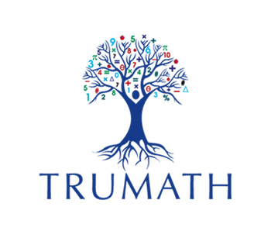

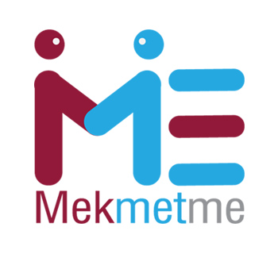

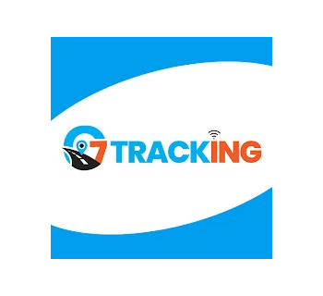

   



   

   

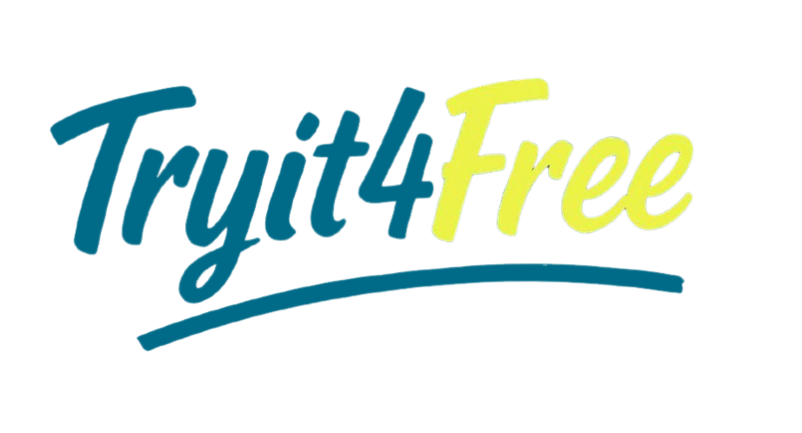   

# CHAPTER 1

# INTRODUCTION TO LANGUAGES, IDE, TOOL AND

# TECHNOLOGIES USED

**1. PYTHON**

Python is a widely used high-level, general-purpose, interpreted, dynamic programming language. Its design philosophy emphasizes code readability, and its syntax allows programmers to express concepts in fewer lines of code than would be possible in languages such as C++ or Java. The language provides constructs intended to enable clear programs on both a small and large scale.

* Python supports multiple programming paradigms, including object-oriented, imperative and functional programming or procedural styles. It features a dynamic type system
* m and automatic memory management and has a large and comprehensive standard library. Python interpreters are available for installation on many operating systems, allowing Python code execution on a wide variety of systems.
* Itis a general-purpose coding language—which means that, unlike HTML, CSS, and JavaScript, it can be used for other types of programming and software development besides web development.

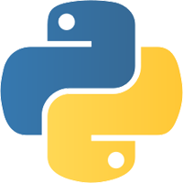

**1.1. Python can be used for things like:**

* Back end (or server-side) web and mobile app development
* Desktop app and software development
* Processing big data and performing mathematical computations
* Writing system scripts (creating instructions that tell a computer system to “do” something)

## 1.2. Why it was called Python

The language’s name isn’t about snakes, but about the popular British comedy troupe Monty Python (from the 1970s). Guido himself is a big fan of Monty Python’s Flying Circus. Being in a rather irreverent mood, he named the project ‘Python’

**1.3. Key Features of Python**

## • Open Source with a Strong Community

Python is an open-source language, which means it is free to use and distribute, even for commercial purposes. This open nature has helped in building a strong community around Python. Developers from around the world contribute to the improvement of the language and its expansive ecosystem of libraries and frameworks.

## • Extensive Libraries and Frameworks

Python’s standard library is very extensive, offering modules and functions for a wide range of tasks. In addition to the standard library, Python’s ecosystem has a vast range of third-party modules. These libraries can help you do everything from sending HTTP requests, to manipulating images, to performing complex data analysis.

## • Compatibility and Integration

Python works on different platforms, meaning it can be used on Windows, macOS, Linux, and even Raspberry Pi. It can easily integrate with other parts of your software stack. Furthermore, Python’s interpretable nature makes it possible to use Python alongside other languages in a larger project

## • Large Community Support

Python has gained popularity over the years. Our questions are constantly answered by the enormous Stack Overflow community. These websites have already provided answers to many questions about Python, so Python users can consult them as needed.

• **Cross-Platform:**

It is a cross-platform programming language, so you can use it on any operating system, including Windows, Linux, Mac, and many more.

### 1.4. Conclusion

Python is a smart and adaptable programming language that has become popular in recent years.

It's easy-to-learn syntax, vast library of functions, modules, and libraries, and support for various programming paradigms make it a perfect choice for a wide array of applications.

From data science to web development, machine learning to automation, Python can be used for almost any task you can imagine.

Learning Python can open up a whole new world of possibilities for aspiring programmers, offering a range of opportunities to build applications that solve real-world problems.

With its vast community of developers, rich ecosystem of libraries and tools, and wide range of applications, Python is a language that's here to stay.

Whether you're just starting out or are an experienced programmer, Python offers a wealth of features and functionalities that can help you build better, more efficient, and more robust applications.

With its ease of use, readability, and broad applicability, Python is a language that every programmer should know.

## 2. DATA SCIENCE

Data science is the analysis of data to find meaningful insights that can be used to inform business decisions. For example, a marketing analyst can use customer transaction data to determine which products customers in one demographic or geographic region buy often and adjust marketing campaigns to target those findings.

Data science is an interdisciplinary field that relies on statistics, scientific computing, algorithms, programming, AI, machine learning, and scientific methods. Because the study and analysis of data are so broad, careers in data science vary greatly. For example, some positions focus on data storage and maintenance, while others are more closely related to journalism, reporting findings from data analysis.

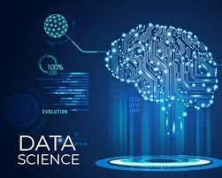

**2.2 Why Data Science Matters**

Ultimately, the primary goal of data science is to help companies make data-driven decisions. Data is ever-growing, and companies need ways to understand their market and customer bases more accurately. As such, the role of data science in business is growing. For example, according to the U.S. Bureau of Labor Statistics, the employment of data scientists is projected to grow 36% from 2021 to 2031.

Some key ways businesses use data science are:

* **Optimization:** Data science allows companies to optimize processes to adapt to changes faster and quickly determine areas of the business that need improvement or are not working as efficiently as they could. Companies also use findings to optimize profitability and marketing campaigns.
* **Innovation:** Data science can help companies craft novel approaches to problems and create new and better business processes.
* **Discovery:** With the help of data science, companies can discover new markets or gaps in product offerings. Data science can also highlight previously unknown problems or redundancies, making companies more efficient.
* **Prevention:** By tracking trends and patterns, companies can avoid future problems. Companies use clean and accurate data to prevent minor issues from growing into ruinous dilemmas. Additionally, data science equips businesses with the tools to adapt to changes quickly and potentially prevent obstacles down the road.

**2.3 Types of Careers in Data Science**

* **Data Scientist**

Data scientists are analytics specialists who analyze and interpret vast amounts of data to find business solutions.

A data scientist is also “an expert in problem-solving and can break down business problems into granular tasks that can be solved using various data science techniques.” says Dushyant Sengar, director of data science at BDO USA.

Some data science techniques include creating statistical models, using software engineering to automate tasks, and working with engineers and business leaders to align company data needs.

* + **Data Analyst**

Similar to data scientists, analysts interpret data to find meaningful insights. However, a data analyst is likely earlier in their career than a data scientist and focuses more on strictly analyzing and reporting. Learn more about the difference between data analysts and data scientists.

* + **Machine Learning Software Engineer**

Machine learning software engineers design, build, and maintain AI systems used to improve the effectiveness of data analysis. Often, this role involves creating models to train the AI programs and testing the quality of outcomes.

* + **Marketing Analyst**

Marketing analysts apply findings from data analysis to marketing decisions. A marketing analyst is responsible for figuring out which products specific markets prefer and tracking the efficacy of different marketing campaigns.

Some marketing analysts work in a specific section of a marketing team. For example, digital marketing analysts focus entirely on online marketing efforts.

**Data Science Tools**

Data Science Tools help implement various steps involved in a Data Science project, such as Data Analysis, Data Collection from databases and websites, Machine Learning model development, communication results by building dashboards for reporting, etc. The most popular tools used in Data Science include -

**Python**

* Python is the most popular and widely used programming language among Data Scientists. One of the main reasons for Python’s popularity in the Data Science community is because of its ease of use and simplified syntax, which makes it easy to learn and adapt for people having no engineering background. The most popular Python libraries used in Data Science are Pandas**,** NumPy**,** SciPy**,** matplotlib**,** Seaborn**,** Scikit-learn**,**, etc.

**R**

* After Python, R is the second most popular programming language used in the Data Science community. It was initially developed to solve the statistical problem but has now evolved into a complete Data Science ecosystem. A few of the most popular R libraries are ggplot2**,** dpylr**,** readr**,** etc.

**SQL**

* SQL stands for Structured Query Language that is used by Data Science professionals to query, update, and manage relational databases and extract data.

**3. DATA ANALYST**

The Data Analyst turns data into insights that companies can use to enhance their decision making processes. Have you ever wondered how big organizations determine which products to create next or how to enhance their services for the future? Well, it's all thanks, to data analysts who go through the data and extract information that benefits the company.

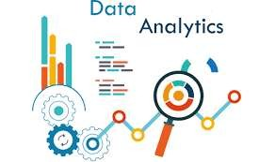

**3.1 What is Data Analytics?**

The process of extracting knowledge from data to support more informed business decisions is known as data analysis. There are normally five iterative stages involved in data analysis:

* + **Stage 1**: Identify the data you wish to analyze.
  + **Stage 2**: Collect the data.
  + **Stage 3**: Prepare the data for analysis, and clean it up.
  + **Stage 4**: Examine the information.
  + **Stage 5**: Interpret the analysis's findings.

**3.2 What are the responsibilities of a Data Analyst?**

A person who gathers and assesses information to tackle a problem is referred to as a data analyst. Besides working with data this occupation also involves communicating discoveries.

Several data analysts perform the following tasks daily:

A. Collect data

* + Analysts frequently assemble data on their own.
  + This can entail carrying out surveys, monitoring the attributes of website visitors, or purchasing data sets from experts in data collection.

B. Clean data

* + Unprocessed data may have mistakes, inconsistencies, or duplicates.
  + To prevent inaccurate or distorted interpretations, cleaning the data entails preserving its quality in a spreadsheet or using a computer language.

C. Model data

* + This comprises building and planning a database's structures.
  + You might decide which data kinds to gather and keep.

D. Analyze data

• Analyzing data entails identifying patterns or trends that will assist you in addressing the current query.

E. 5. Present

• One of the most important aspects of your work will be sharing the findings with others. • You compose reports, make visual representations like graphs and charts, and give information to interested parties.

F. 6. Analyze data

• Analyzing data entails identifying patterns or trends that will assist you in addressing the current query.

G. 7. Presentation

• One of the most important aspects of your work will be sharing the findings with others. • You compose reports, make visual representations like graphs and charts, and give information to interested parties.

**3.3 Conclusion**

The demand for data analysts is expected to rise offering career prospects with competitive pay and diverse opportunities in various fields. By investing in education acquiring certifications and gaining experience individuals aspiring to become data analysts can position themselves for success, in this industry. Also, consider our Data Science with Python Course for a better understanding of data analysis content.

## Library & packages

## I. PANDAS

pandas is an open-source library that provides high-performance, easy to use data structures and data analysis tools for Python. The name “pandas” actually comes from the term “panel data”, an economics concept referring to multidimensional structured data sets.

Some of the key data structures in pandas are:

* Series: A one-dimensional labeled array capable of holding data of any type.
* DataFrame: A two-dimensional tabular data structure with labeled columns and rows. Similar to a SQL table or Excel spreadsheet.

On top of these structures, pandas provides a host of data manipulation and analysis methods that make working with labeled, structured data fast, efficient, and intuitive in Python.

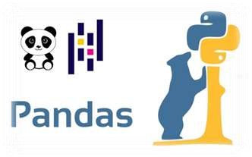

**Why Use pandas?**

pandas offers Python programmers an extremely intuitive and feature-rich interface for working with labeled, tabular data. Here are some of the key reasons pandas is a go-to tool for data analysis in Python:

* **Fast and efficient:** Operations like aggregations and groupby are optimized to provide high performance on large data sets.
* **Powerful data structures:** The DataFrame and Series objects allow intuitive access to data and metadata.
* **Intuitive syntax:** Operations like merging, reshaping, slicing, selecting, and transforming data sets mirror conventions from other coding languages and domains.
* **Built-in visualization:** Integration with Matplotlib makes plotting and visualizing data sets quick and easy.
* **Handy data manipulation:** Methods like drop(), fillna(), pivot(), and groupby() provide easy ways to wrangle messy data sets.
* **Interoperability:** pandas integrates nicely with other core Python data science libraries like NumPy and scikit-learn.

In short, pandas combines the high performance and flexibility of NumPy with the easy to use and intuition of spreadsheet programs like Excel. This makes interactive data analysis and munging in Python a productive and enjoyable experience.

## II. NUMPY

NumPy is a Python library that provides support for large, multi-dimensional arrays and matrices, along with a large collection of high-level mathematical functions to operate on these arrays. With a reputation for high performance, it is often used for scientific computing tasks, such as:

* Mathematical operations like linear algebra, Fourier transform, and random number capabilities.
* Tools for integrating C/C++ code.
* Extensive capability to process large multidimensional arrays and matrices.

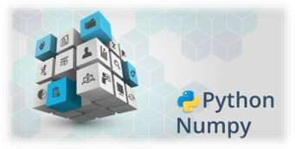

**Why use NumPy?**

* As a data scientist, you will be dealing with large datasets that contains thousands of rows and columns.
* Using the traditional Python lists makes data preprocessing and analysis slower, especially because lists take up more memory space. Also, working with lists can quickly become lengthy and tiresome because of the many lines of code required to achieve a particular result.
* NumPy is able to achieve all these because of arrays. Arrays reduce the overall size of the code, and because each array contains data of the same type, this speeds up computations and makes it easier to store and manipulate large amounts of data.

## III. Matplotlib

Matplotlib is a low-level or 2-dimensional plotting Python library that helps in data visualization. It is an open-source and free library created by John Hunter.

Matplotlib is a multi-platform library built on NumPy arrays and designed to work with the broader SciPy stack. It is mostly written in python with a few segments written in C, ObjectiveC, and Javascript for Platform compatibility. It can be used in different graphical user interface toolkits such as python scripts, shell, web application servers, etc.

Pyplot is a module in the Matplotlib module which provides a MATLAB-like interface. With this, we can build line plots, histograms, bar charts, scatter plots, etc. In addition, we can also set the features for these plots which include labels, font properties, axes properties, line styles, etc.

## Here is the different methods to visualize the data using matplotlib =>

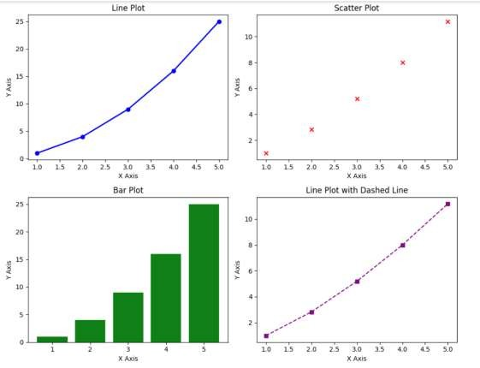

*Figure 7*

## IV. SEABORN



Seaborn is an open source Python library built on top of a matplotlib. Used for data viewing and analysis of test data. Seaborn easily works with data frames and the Pandas library. Created graphs can also be customized easily. Below are a few of the Data Identification Benefits.

* Graphs can help us find useful data trends for any machine learning or prediction project.
* Graphs make it easy to present your data to non-technical people.
* Attractive graphs can make presentations and reports more appealing to the reader.
* Seaborn is an amazing data visualization library for editing mathematical graphics in Python. Provides beautiful automated styles and color palettes to make mathematical pieces more attractive. Built on top of the matplotlib library and reassembled near data structures from pandas. In this tutorial, we will look at how to use seaborn to make a variety of sites and how to use them and matplotlib to make our sites more attractive.

**Features of Seaborn:**

Seaborn is made on the Python core library Matplotlib. it’s supposed to function as a complement, not a substitute. However, Seaborn comes with some vital options. Let’s have a look at many of them here. options facilitate –

* Designed with themes to vogue matplotlib graphics.
* Visualize static and quantity information.
* Installation and visual image of retrospective models.
* Rich information statistic statistics.
* Seaborn works well with NumPy and Pandas information structures.
* Comes with intrinsic themes for Matplotlib vogue drawings.
* In most cases, you’ll still use Matplotlib to form an easy plot. Matplotlib info is usually recommended to mend Seaborn default sites.

## V. PLOTLY EXPRESS

As a data scientist or analyst, you have likely used Matplotlib for visualizing data, but if you are looking for a more interactive, flexible, and user friendly tool, Plotly Express is a game changer. Whether you are analyzing data, presenting insights, or creating dashboards. Plotly Express gives you a simpler way to build interactive visualizations without the hassle of extensive coding.

-> Why Plotly Express for Data Scientists?

Here’s why Plotly Express is ideal for data science:

* Fast Prototyping: You can create high-quality plots in just a few lines of code, allowing you to focus more on analysis and less on the nitty-gritty of plot design.
* Interactivity: Built-in interactivity is great for exploratory data analysis (EDA) and communicating insights with non-technical stakeholders.
* Web Compatibility: Perfect for embedding visualizations in web apps or sharing reports via dashboards.

Here are different visuals if you see data with plotly express =>

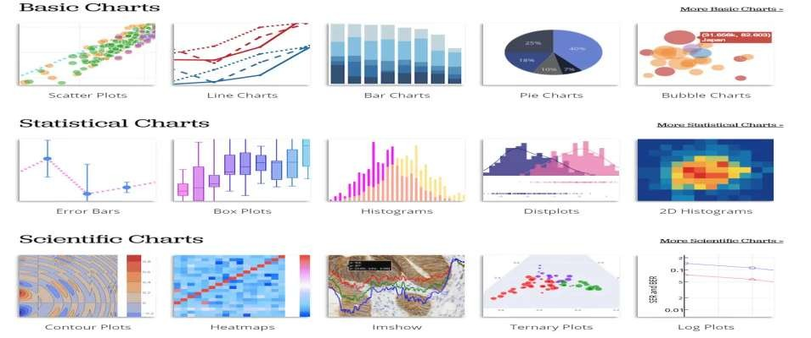

*Figure 8*

**4. TOOLS AND EDITORS**

**I. IDLE**

*Figure 9*

Python IDLE (Integrated Development and Learning Environment) is an integrated development environment for Python that comes bundled with the standard Python distribution.

It serves as a convenient tool for writing, testing, and debugging Python code.

Python IDLE provides a graphical user interface (GUI) that simplifies the coding process and helps users manage their Python projects efficiently.

Python's IDLE capability enables programmers to write and execute a single line of code, much as how Shell writes and edits code.

It is extremely user-friendly, especially for novices, due to features like intelligent indentation and highlighting. This and many other aspects make Python one of the preferred choices for beginners to progress in their programming journey.

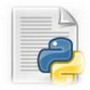

**IDLE features:**

* Cross Platform : Works on Unix and Windows.
* Multi-window text editor with syntax highlighting and smart indent and other.
* Python shell window with syntax highlighting.

GUI OF IDLE=>

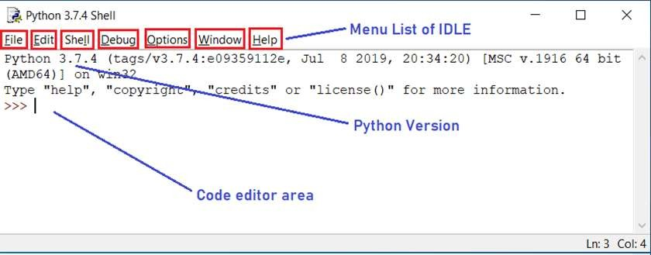

*figure9. 1*

**II. VISUAL STUDIO CODE ( VS CODE )**

Visual Studio Code, affectionately known as VS Code, is a free tool created by Microsoft that helps you write and manage code.

Think of it as a sophisticated text editor, like Microsoft Word, but instead of formatting letters and reports, it's designed to help you write and organize computer code for websites, apps, and software.

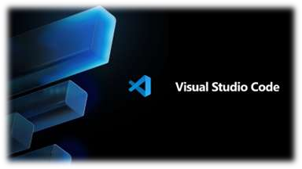

**Key Features of VS Code That Make Coding Accessible**

* **Extensions for Everything:** Just like adding apps to a smartphone to increase its functionality, VS Code allows you to install extensions to support different languages (like HTML for websites, Python for data science, or JavaScript for web applications) and tools to make coding easier and more efficient.
* **Guided Code Writing:** VS Code comes with something called IntelliSense, which is like having a helpful assistant that suggests how to complete your lines of code, identifies typos, and even explains what certain commands do. This feature is incredibly beneficial for beginners learning the ropes.
* **Integrated Git Support:** Imagine writing a long document and wanting to save different versions as you make significant changes. Git is a system that lets you do this with code. VS Code has built-in Git support, making it easier to track changes, save different versions of your project, and collaborate with others.
* **Debugging Tools:** Debugging is the process of finding and fixing errors in your code. VS Code has built-in tools to help you identify where things went wrong, allowing you to solve problems without leaving the app.
* **Personalize Your Workspace:** With customizable themes, icons, and shortcuts, VS Code lets you create a coding environment that feels comfortable and personal, making the learning process more enjoyable.

**Limitations of Visual Studio Code (VS Code)**

VS Code feels like a godsend after reading Visual Studios limitations, right? But hold your horses, for this software has its limitations too.

* **Less Integrated:** VS Code doesn’t come with many integrated dev tools. While this makes it lightweight, it also means that significant setup via extensions is often necessary to match the functionality of a full IDE. It also requires manual setup for compilers, debuggers, and language-specific features.
* **Extension Reliance:** The need for extensions for even basic functionalities like syntax highlighting, debugging, etc, can lead to dependency issues or conflicts between extensions. This can sometimes result in an inconsistent development environment or require time spent managing extensions.
* **Performance with Extensions:** While VS Code is inherently fast and efficient, loading it with numerous extensions can bog down its performance, making it less snappy than it is intended to be.
* **Comparatively Less Advanced Debugging:** VS Code’s debugging tools, though robust, are not as advanced or seamless as those found in a full IDE like Visual Studio. For complex applications, particularly large enterprise levels, this might be a constraint.
* **Less ideal for C# centric Applications:** Compare to Visual Studio setting up VS Code to work with C# can be a hassle and would still lack some functionalities provided by Visual Studio.

# JUPITER NOTEBOOK

When you think of a notebook, you probably imagine a collection of blank pages that you can use to write down your thoughts or make notes. What if we told you that notebooks aren't limited to paper? What if a new kind of notebook lets you do everything and more? That's right: the Jupyter Notebook!

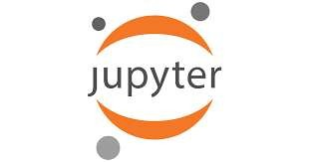

The Jupyter Notebook is a Python-based user interface where users can work with an ordered list of input/output cells to achieve Python Web server-related tasks and deposit code solutions. Users can also run code cells in parallel, view the results of their work as they type it in, and interact with other users via messaging systems built into the application.

Jupyter Notebooks are a popular tool for data scientists and those who like to do some statistics on the side. The notebooks allow users to write their code in one place, then send it off to the Jupyter kernel, which interprets the code and displays the results. Additionally, users can also set up different kernels for different languages.

Users can use this feature to write their code in R, Python, Julia, or other popular programming languages and see how it will react before they run it live on their computer. So what makes this new kind of notebook so special? It's simple: it allows people to do more than ever before— and it makes learning more accessible than ever before too!

# GOOGLE COLLAB

Google Colab is a Jupyter Notebook-like product from Google Research. A Python program developer can use this notebook to write and execute Python program codes just using a web browser.

In a nutshell, Google Colab is a cloud-hosted version of Jupyter Notebook. To use Colab, you do not need to install and runtime or upgrade your computer hardware to meet Python’s CPU/GPU intensive workload requirements.

Colab gives you free access to computing infrastructure like storage, memory, processing capacity, graphics processing units (GPUs), and tensor processing units (TPUs).

Google has specially programmed this cloud-based Python coding tool, keeping in mind the needs of machine learning programmers, big data analysts, data scientists, AI researchers, and Python learners.

The best part is one code notebook for all the components needed to present a complete machine learning or data science project to program supervisors or sponsors. For example, your Colab notebook can contain executable codes, live Python codes, rich text, HTML, LaTeX, images, data visualizations, charts, graphs, tables, and more.



**Google Collab Features**

* Cloud Storage
* GitHub Integration
* Multiple Data Sources
* GPUs and TPUs
* Pre-installed Libraries

# STREAMLIT

Streamlit is a Python-based framework that allows developers to create interactive web applications with minimal effort. It’s particularly useful for data-driven applications, enabling seamless integration with popular libraries like Pandas, NumPy, and Matplotlib. With Streamlit, you can quickly build and share data apps without needing extensive web development experience.

**a) Use Cases of Streamlit**

* **Data Visualization**: Create real-time interactive dashboards.
* **Machine Learning**: Deploy models with interactive UI.
* **Business Analytics**: Build reporting dashboards with data insights.
* **Prototyping**: Rapidly develop and test ideas without web development expertise.
* **Education**: Create interactive learning tools and simulations.
* **Automated Reporting**: Generate auto-updating reports with a user-friendly interface.

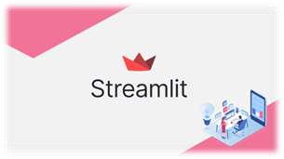

**b) Key Features of Streamlit:**

* **Fast & Simple:** No need for additional web technologies, just Python.
* **Interactive Widgets:** Use sliders, buttons, text inputs, and more for user interaction.
* **Live Code Updates:** The UI auto-refreshes when the script changes.
* **Performance Optimization:** Speed up apps with built-in caching @st.cache_data.
* **Data Visualization Support:** Supports Matplotlib, Plotly, Seaborn, Altair, and more.
* **Easy Deployment:** Deploy instantly via Streamlit Cloud, AWS, GCP, or Azure.
* **API Integration:** Easily integrate with RESTful APIs, databases, and cloud storage.
* **Customization:** Use themes and CSS modifications to enhance the UI.

**Chapter :2**

**References And Bibliography**

* **Kaggle Datasets – Global Unemployment**[**https://www.kaggle.com/datasets**](https://www.kaggle.com/datasets)
* **Python Official Documentation**[**https://docs.python.org**](https://docs.python.org)
* **Pandas Documentation**[**https://pandas.pydata.org**](https://pandas.pydata.org)
* **NumPy Documentation**[**https://numpy.org**](https://numpy.org)
* **Matplotlib Documentation**[**https://matplotlib.org**](https://matplotlib.org)
* **Seaborn Documentation**[**https://seaborn.pydata.org**](https://seaborn.pydata.org)
* **Plotly Express Documentation**[**https://plotly.com/python/plotly-express/**](https://plotly.com/python/plotly-express/)
* **Streamlit Documentation**[**https://streamlit.io**](https://streamlit.io)
* **Google Colab**[**https://colab.research.google.com**](https://colab.research.google.com)
* **Visual Studio Code (VS Code)**[**https://code.visualstudio.com**](https://code.visualstudio.com)